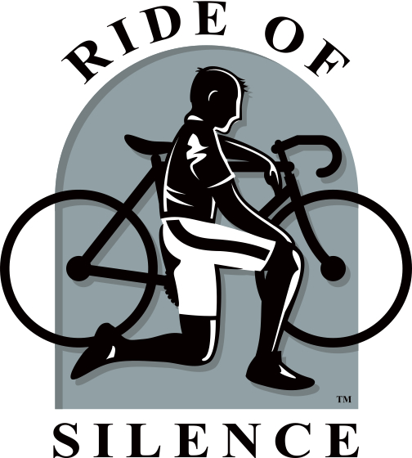

A FREE COMMUNITY EVENT
Wednesday, May 18th, 5:30pm
The Lakes of Thousand Oaks
2200 E. Thousand Oaks Blvd., Thousand Oaks
Gather - 5:30pm
Pre-Ride Ceremony - 6:00pm
Ride - 6:30pm
Join the Ride of Silence on Wednesday, May 18th at The Lakes of Thousand Oaks @ 5:30pm to honor fellow bicyclists who have been injured or killed by motorists. The Ride of Silence allows us the opportunity to help raise awareness of bicyclist’s rights to the road, and to let motorists, the public, and bicyclists know we all share the same roads. Join fellow bicyclists in solemn remembrance on a short 10 mile ride escorted by the Thousand Oaks Police on roads we all share. By taking part in the Ride of Silence, you will help educate drivers to be more vigilant when approaching cyclists on roads we share.
HELMETS MANDATORY!
All participants under the age of 18 years must be accompanied by a parent.
Special thanks to The Lakes of Thousand Oaks for use of their facilities.
Hosted by the City of Thousand Oaks

