Website: VCFD.org | CONTACT: Heather Sumagaysay
Facebook: @VenturaCountyFire | Public Information Officer
Twitter: @VCFD | PHONE: (805) 389-9746
 | EMAIL: PIOFire@ventura.org
NEWS RELEASE
FOR IMMEDIATE RELEASE
April 28, 2017
MEDIA INVITE
Bike ‘n’ Ride with VCFD: New bicycle repair stand unveiled during event

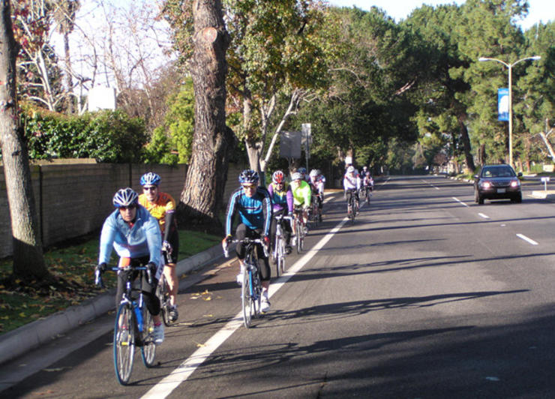
THOUSAND OAKS, CA – You’re invited to join Ventura County Fire (VCFD) for a family-friendly, 10-mile recreational ride on Monday, May 15, 2017, to inaugurate the installation of the department’s first public bicycle repair stand.

(NOTE TO MEDIA: Complimentary demo bikes are available for the ride. To reserve a spot, please contact TabethaKay@GiantBicycle.com with Giant Bicycle).

Led by cycling enthusiast Jack Nosco (VCFD Fire Captain), participants will travel from Giant Bicycle in Newbury Park to Fire Station 33 in Thousand Oaks, where friends and families will cheer on riders as they cross the finish line.

Timeline of Events:
- 8:15 a.m. – Event check-in at Giant Bicycle, located at 3587 Old Conejo Rd., Newbury Park, CA 91320.
- 9 a.m. – Rider departure
- 9:30 – 9:45 a.m. – Cyclist arrival at VCFD Fire Station 33, located at 33 Lake Sherwood Dr., Thousand Oaks, CA 91361
- 10 a.m. – Unveiling event of new bike repair stand at Station 33

Visuals: Dozens of bicycles, avid cyclists, and excited community members riding together. Riders include VCFD firefighters, dignitaries, County officials, Giant Bicycle employees, and cyclists from various bike clubs.

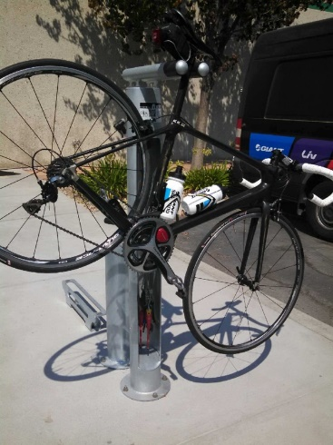
Whether it’s changing a flat or adjusting brakes and derailleurs, the bike repair stand features an air pump, tools and mounts so riders can securely hang a bike and make adjustments. The repair station is one of 16 stands to be installed by the County. Additional units will be located in high traffic biking communities near fire stations.

Ventura County is a well-known destination for cyclists, and many of its communities feature bike-friendly paths and roadways. The bike repair stands are intended to promote healthy activities in neighborhoods and prevent cyclists from becoming stranded.

The free Bike ‘n’ Ride event is sponsored by County Supervisor Linda Parks and Giant Bicycle in support of the County’s “Health in all Policies” resolution adopted on January 27, 2015. The event also coincides with National Bike to Work Week, happening
May 15-19, 2017.

To attend, please RSVP by Wednesday, May 10, through Eventbrite at https://bikenridewithvcfd.eventbrite.com. All who participate must wear a helmet. Contact VCFD PIO for questions at (805) 389-9769.

